# 

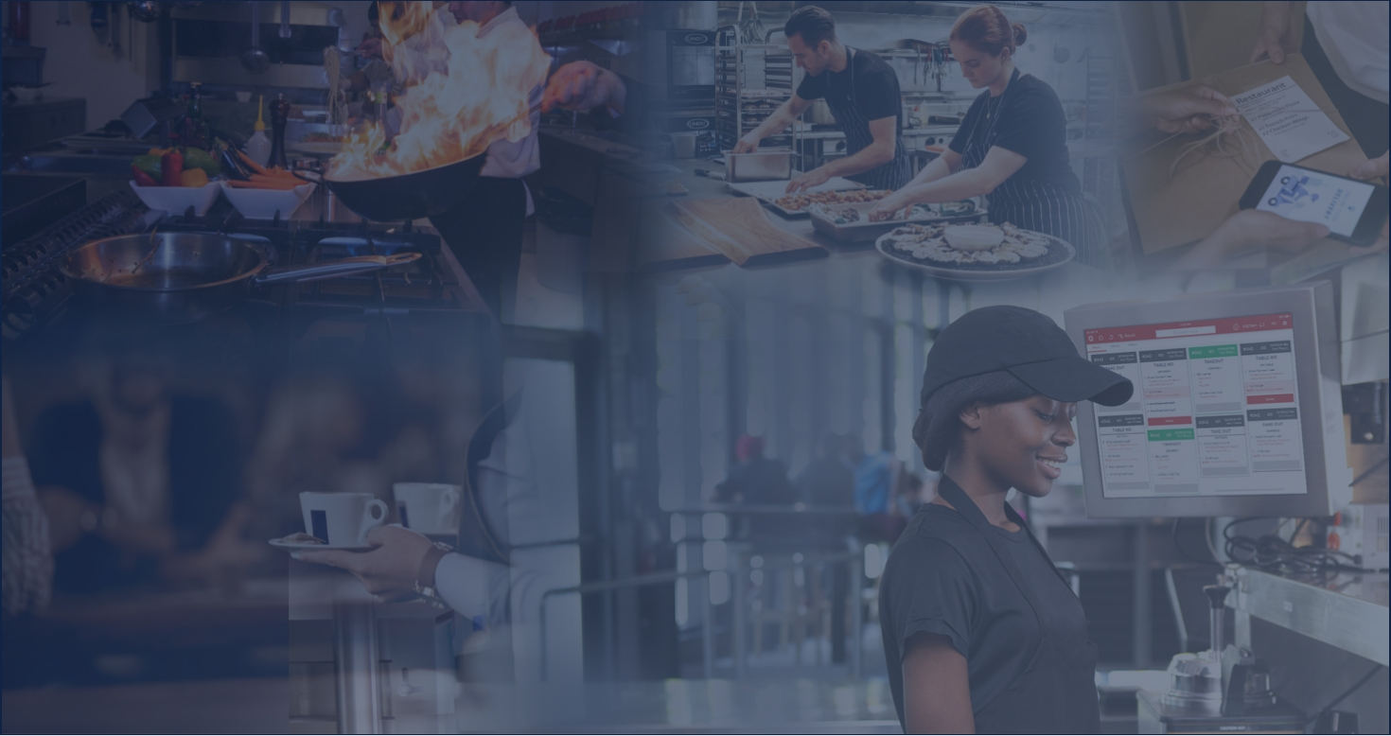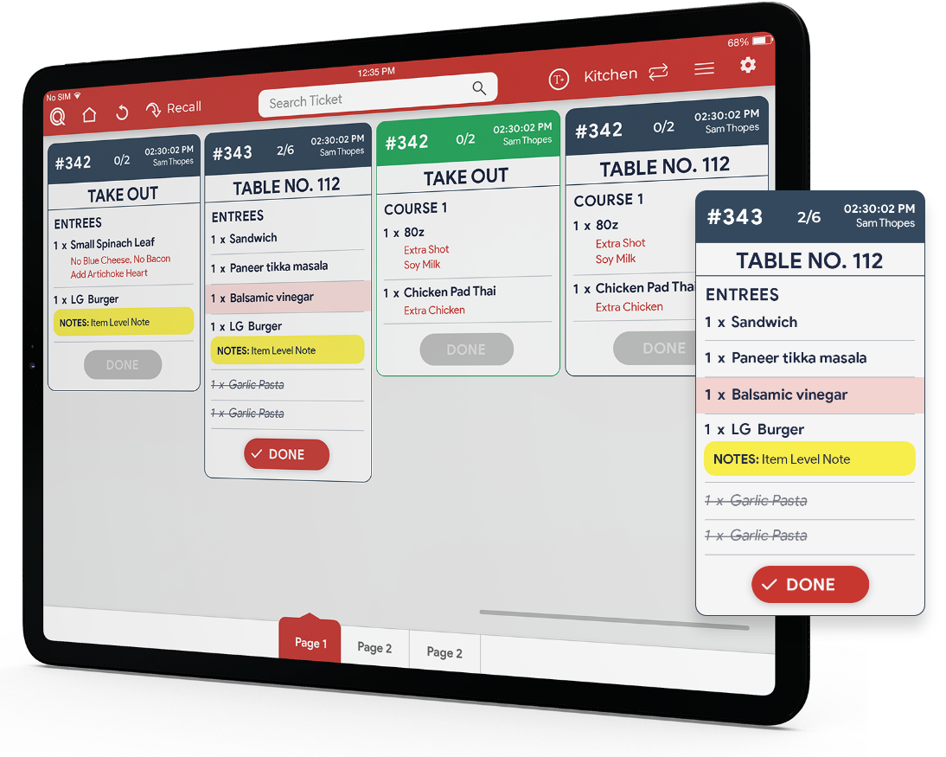

**KDS**

**User Manual**

**Table of Contents**

**KDS (Kitchen Display System) 2**

**KDS Login Screen 2**

**Access multiple locations using one username 3**

Add Multiple Stations 3

Multiple screen options 3

Kitchen Display 5

Icons and their descriptions 6

Toolbar icons 7

Ticket Header Icons 8

Coursing 10

Item List 10

Notes 11

Order Management Features 12

Expo Display 13

Color Coding the Tickets (New Turns Old) on Quantic KDS 14

Color coding the old tickets 14

Color coding the new tickets 14

Setup the new ticket duration 15

Bumping the Ticket from Kitchen to Expo Screen 16

Item-level bumping 17

Order-level bumping 18

Sound Notifications for New Orders on Quantic KDS 19

## KDS (Kitchen Display System)

Quantic Kitchen Display System is an advanced digital order viewer that replaces conventional kitchen tickets and kitchen printers. It provides a seamless connection between the front of the house and kitchen staff so that the customers can be served delicious meals without any delay.

## KDS Login Screen

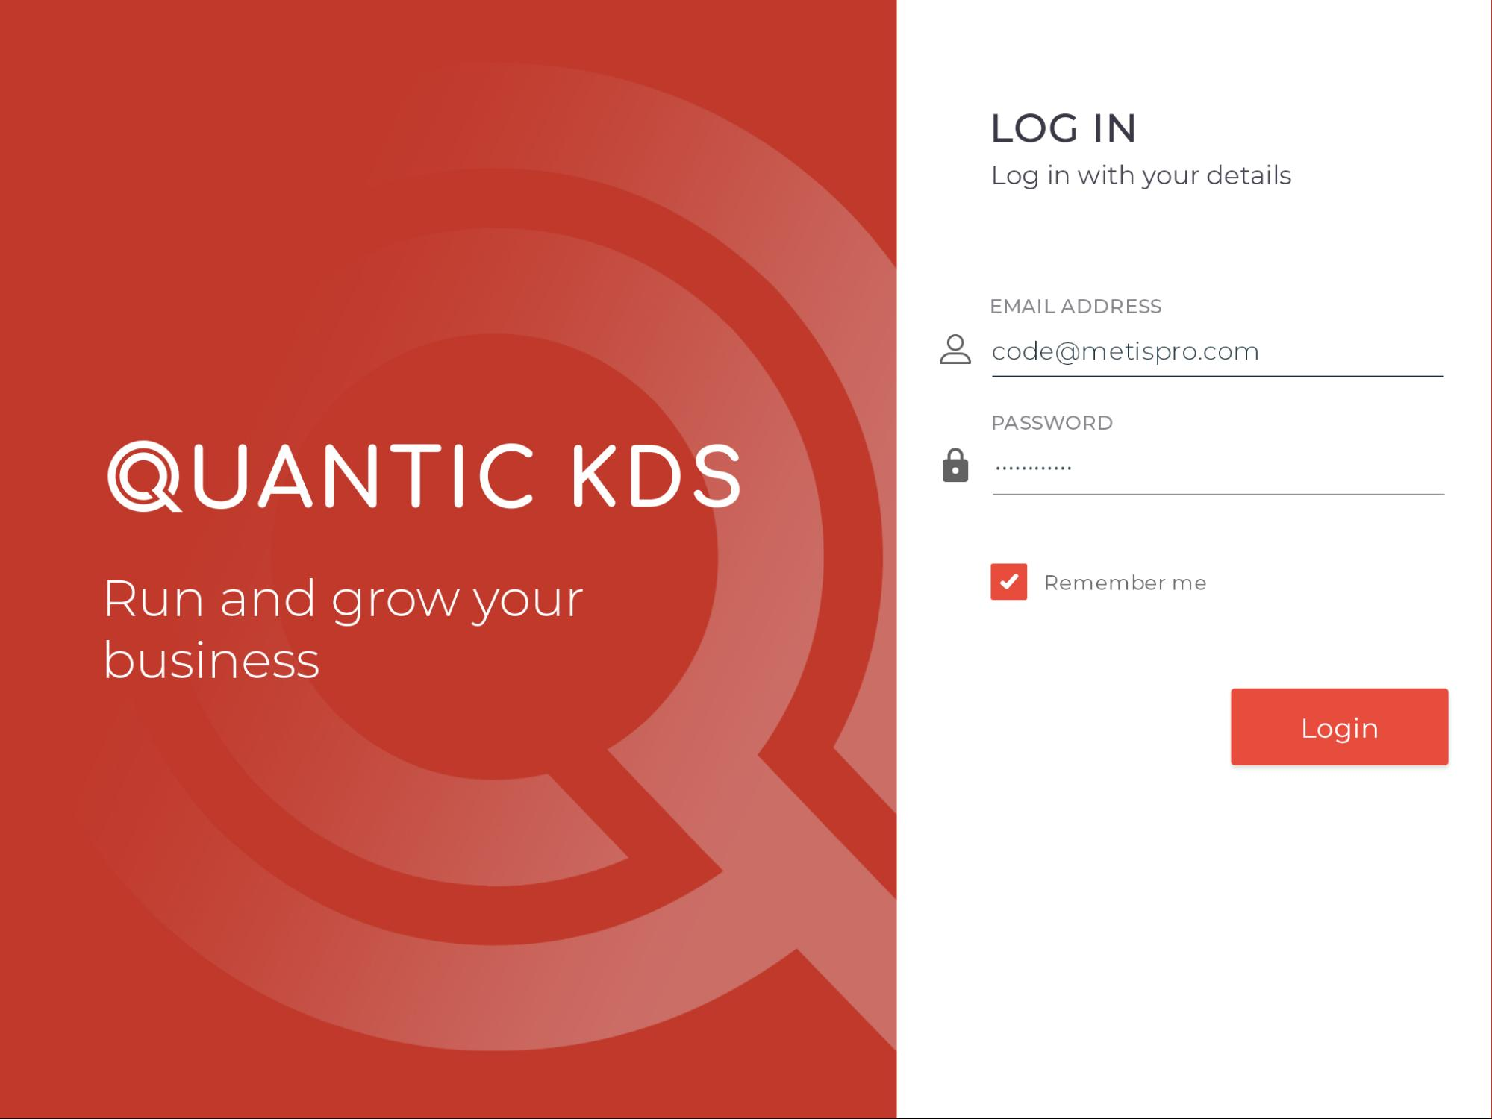

1. This is the Quantic KDS login screen. You can access it with login credentials using a registered **Email Address** and **Password**.
2. If you don’t have the login credential, you can get them from the onboarding team.
3. Once you enter the login details, make sure to mark the checkbox adjacent to **Remember Me** option so that you don’t have to re-enter the login credentials again.
4. Please contact the Quantic support team if no user is assigned to your KDS location**.**

## Access multiple locations using one username

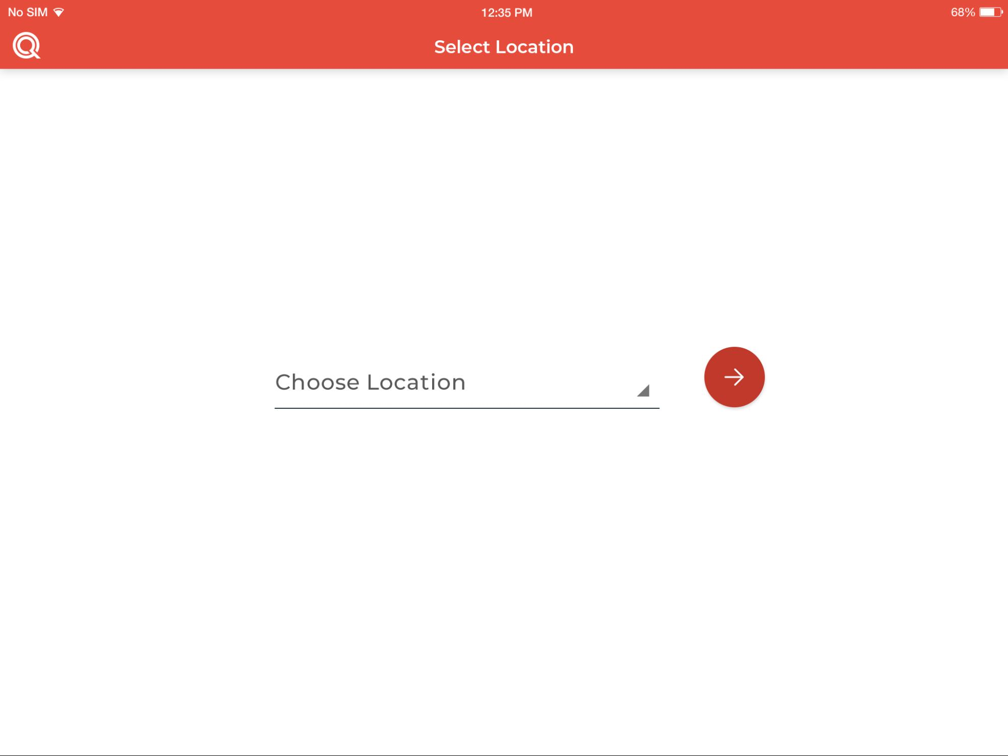

1. Quantic KDS allows you to access multiple locations of your restaurant through one username. Here is the screen on which you can choose the preferred location.

## Add Multiple Stations

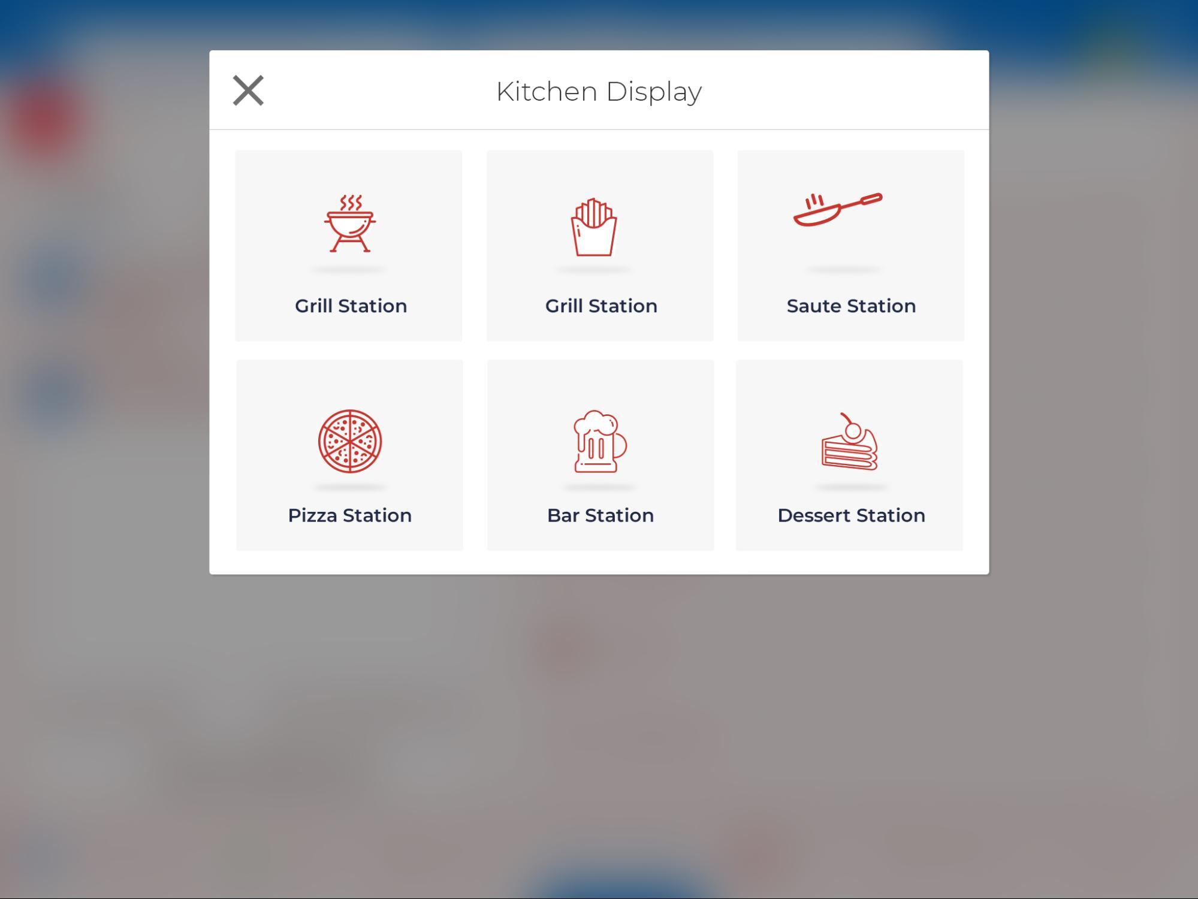

1. Quantic KDS allows you to add multiple stations and customize them as per your needs. Once you have added the required stations, you can choose the stations for which you want to see the KDS screen. Check out the above screenshot, you can simply tap on any of the stations to land on that station’s KDS screen.

## Multiple screen options

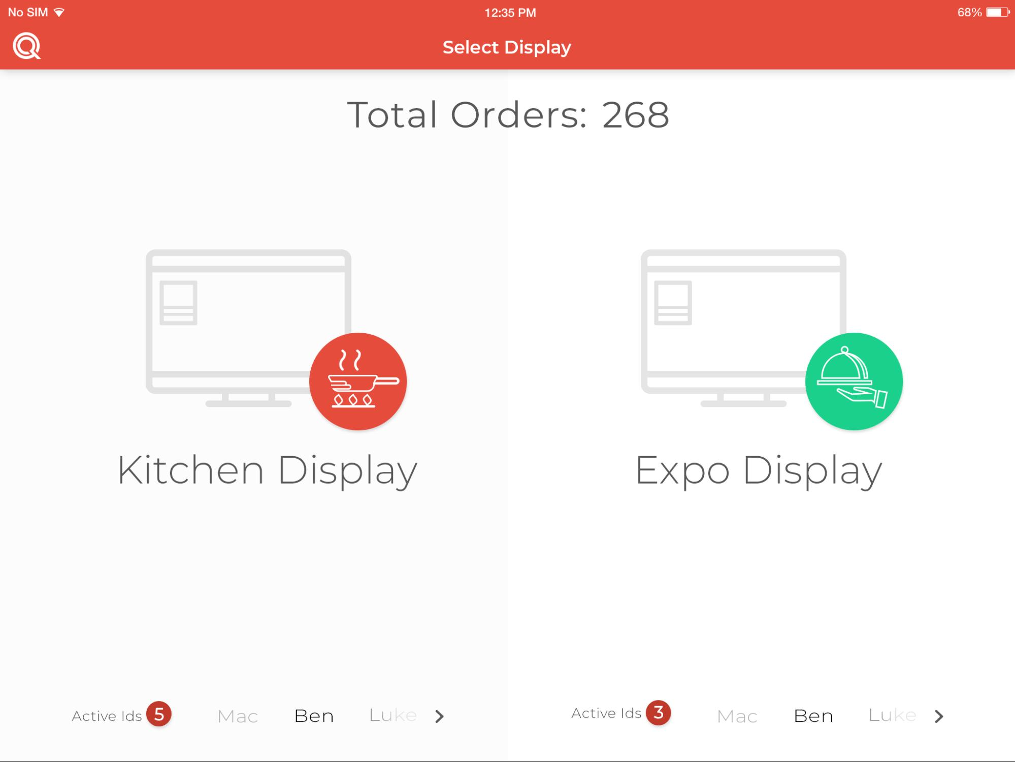

1. After adding and selecting the desired station,you can also choose which display you want to view on the screen - **Expo Display** or **Kitchen Display.**
2. Select the display you want to view, tap on it and you will see the desired display showing all the current orders in the kitchen.

## Kitchen Display

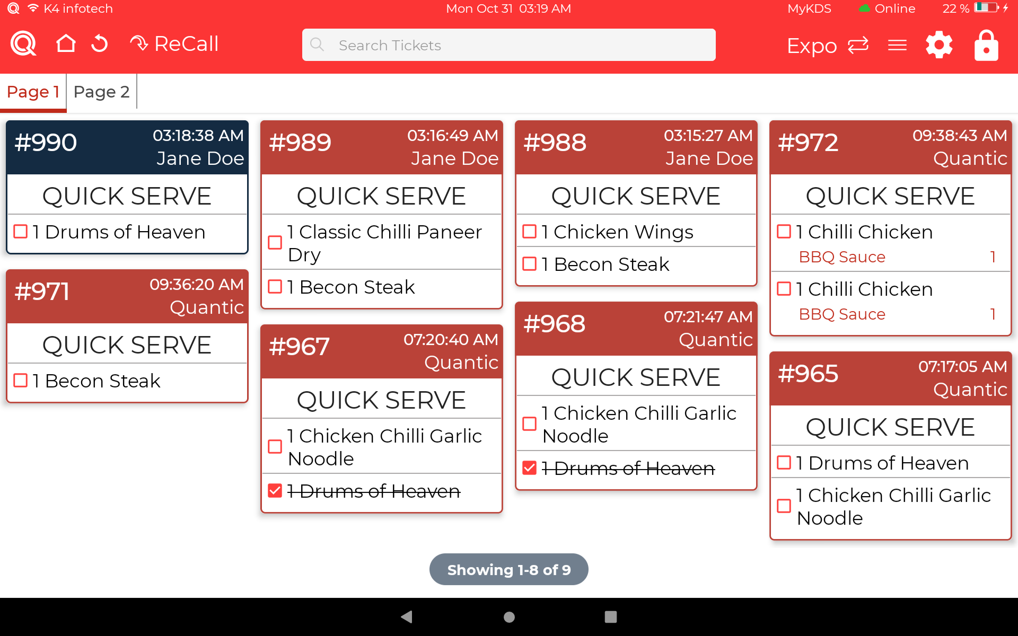

1. The Kitchen screen displays all orders for the kitchen. It allows one-stop order processing and gives you complete control of the preparation times.
2. In the Kitchen display, you can **Bump**, **Recall Orders,** or select items ready to serve using a simple touch.
3. The above screenshot displays the Kitchen Display of Quantic KDS.
4. Next are some terminologies that you should know before start using the Kitchen Display System.

### Icons and their descriptions

The KDS screen has many icons on the top and on the ticket to help you smoothly navigate through the KDS and perform the essential operations. Here are the detailed descriptions of all the KDS icons.

#### Toolbar icons

If you are not able to see the entire toolbar as shown in the screenshot below, please tap the topmost section (red bar) on the KDS and the toolbar icons should start appearing.

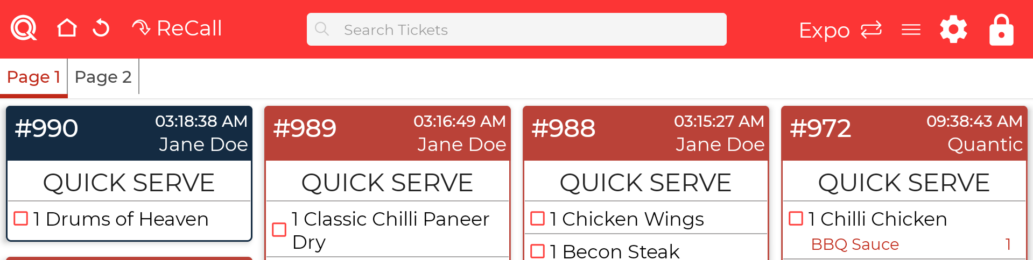

* The  Home button takes the user to the **Select Station** screen where the user can select a different KDS station.
* The  Refresh button allows the user to refresh the screen to check for any updated information on tickets.
* The  button allows the user to recall recently done tickets back to the screen. You can recall and reprocess the bumped orders by clicking the **Recall** button. This is a configuration-based setting, so the time period needs to be set in “Clear All KDS Recall Ticket Time”.
* The  bar allows users to search the orders using the order number.
* The  button allows the user to toggle between the Expo Display and Kitchen Display. When Kitchen Display is on the screen the button will show , you can click on it to navigate to the Expo Display and vice versa.
* The  Navigation button provides a drop-down menu to the users from where they can navigate to different options - **Order By**, **Group By,** and **Clear All Tickets**.
* The  Settings button will take the user to the **Settings** page where they can customize the KDS according to their preferences.
* The  **Lock** button locks the KDS screen and redirects the user to the login screen.
* **Bump** - Once each item in an order is ready, you can double-tap the ticket on the Kitchen screen. It will send a signal to the front of the house regarding items that are ready to be served.

#### Ticket Header Icons

The ticket **header** gives information about the **service area, payment status, time,** and **server.** The header is customized to change color according to the time elapsed which is configurable by the **KDS** user.

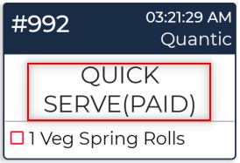

1. The mid-section of the header shows the service area in which the order is taken and its payment status.
2. If the order is paid, it will show **Paid** alongside the service area name as shown in the above screenshot. Here the Service Area is “Quick Serve” with the Status “Paid”.

|  |  |
| --- | --- |
| **Order Start Time** | **Server Name** |

1. On the header top right, you can see the time (in HH:MM:SS format) at which the ticket was sent to the kitchen.
2. Underneath the time, you can see the name of the server who has taken the order.

|  |  |
| --- | --- |
| **Order Number** |  |

1. On the header top left, you can see the **order number** (**#986**). The header color may change based on the time elapsed or as configured from the settings section.

#### Coursing

|  |  |
| --- | --- |
| **Course Name** |  |

1. Quantic KDS shows coursing on the tickets. If coursing is enabled for an item or category, it will be displayed on the KDS screen as shown in the image above.
2. Here Entrée is the course for all three items.

#### Item List

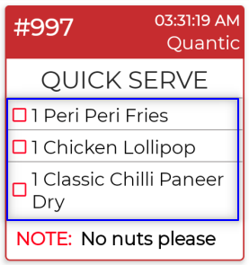

1. The ticket shows the list of items in an order. Once an item is prepared in the kitchen, the chef can just tap on the checkbox adjacent to that item and the item name will strike off from the list.
2. The completed items from the kitchen will go to the **Expo screen**. Once an item is served, the **Expo** can double-tap the ticket to remove it from the queue.

#### 

#### Notes

|  |  |
| --- | --- |
| **Item-level note** | **Order-level note** |

1. To not miss any detail and to avoid dishes returning, Quantic shows the item and order-level notes on the KDS tickets. It helps chefs and expo to make sure of any special instruction requested by the customer.
2. The **item level notes** are shown just below the item whereas the **order level notes** have their separate section under the item list.

#### 

#### Order Management Features

* **KDS Auto Bump** - This will hide the ticket from the kitchen display once the total order amount has been paid. Further, the ticket will start flashing on the Expo screen.
* **First in First Order Option** - It will display the first order in the first position.
* **Last Order in First Order Option** - It will display the last order in the first position.
* **Recall Tickets** - This option allows you to recall the order for reprocessing.
* **Set Customer Number of Columns and Rows** - This allows you to set the number of columns and rows as per the customer count.

## Expo Display

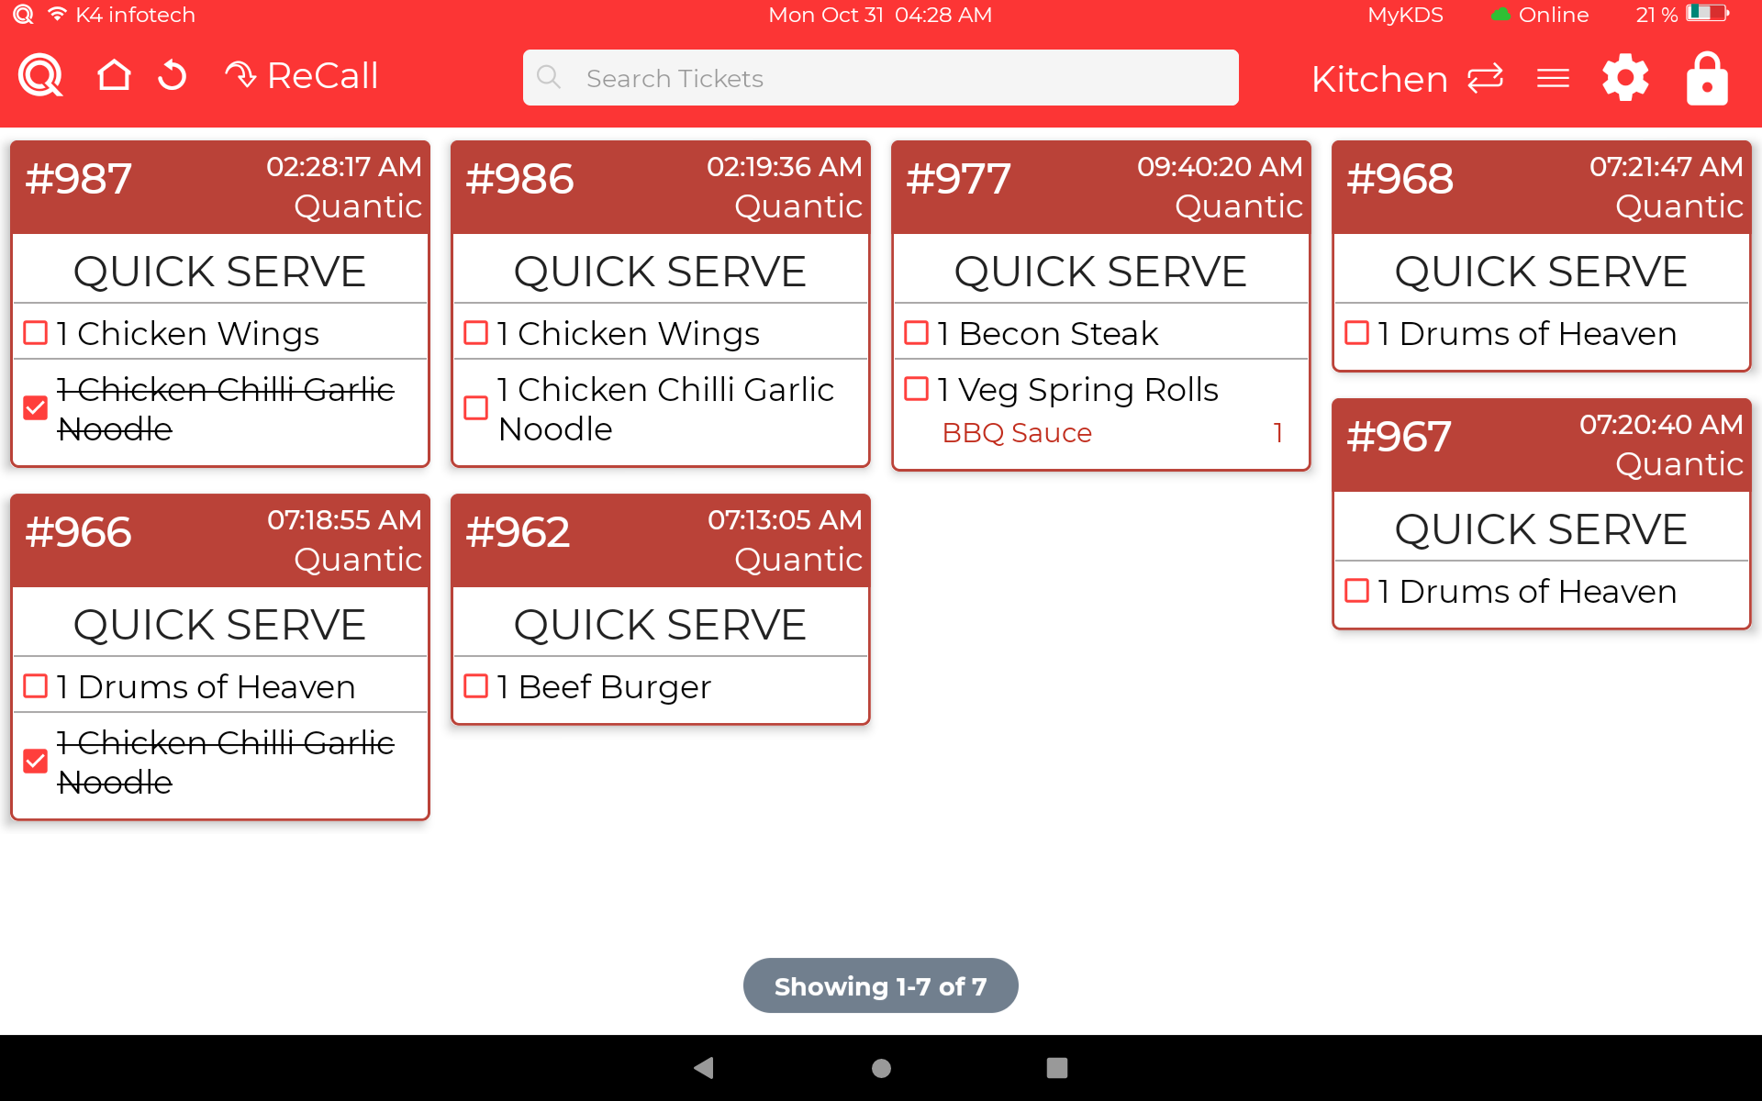

This is what the Kitchen Display Screen looks like. Every ticket consists of the item name, and quantity and has a service area written on the top. It also mentions the serving employee’s name. Once the order is served, the expo can double-tap on the ticket to remove the order from the queue.

Here are some essential features that make the Quantic Kitchen Display System the most needed in your kitchen.

* The tickets in Quantic KDS contain every important detail which makes it easy for chefs to not miss anything in the order.
* Seamless integration with the Point of Sale system.
* You can adjust the screen visibility by increasing or decreasing the font size.
* Change the header color as per your choice.
* Recall tickets feature.
* **New ticket alert** - You can set the alert for a new ticket. Once set, KDS will beep when a new ticket arrives on the KDS screen.

## Color Coding the Tickets (New Turns Old) on Quantic KDS

Here you will learn the steps to customize the kitchen ticket on the KDS screen. New and old tickets can be displayed in different colors in order to help the chefs identify the new ticket from the rest.

### Color coding the old tickets

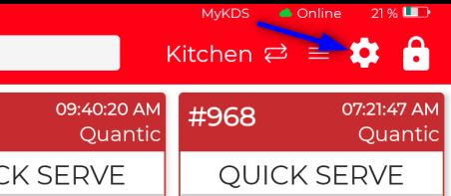

1. Click the  icon on the KDS to go to **Settings**.

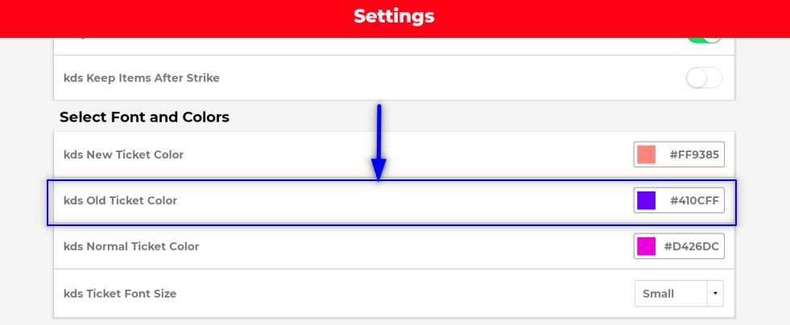

1. Search the configuration **KDS Old Ticket Color**.
2. Select the color from the color picker and click **Save**.

### Color coding the new tickets



1. Click the  icon on the KDS to go to **Settings**.

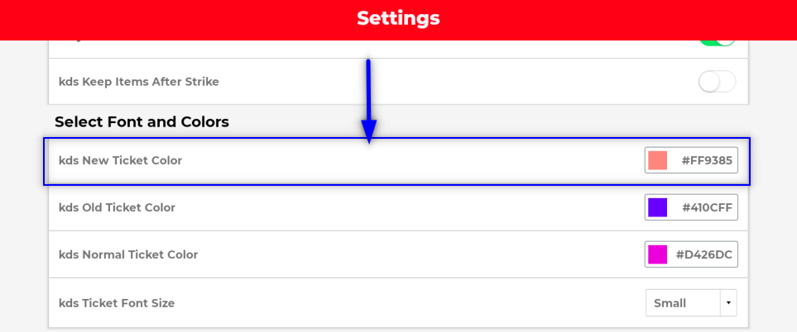

1. Search the configuration **KDS New Ticket Color**.
2. Select the color from the color picker and click **Save**.

### Setup the new ticket duration

You can set up the time interval for new tickets to appear new (identified with a different color than the old ticket) on the KDS screen. Post the set duration, the ticket color will change to the old ticket color. Here are the steps.



1. Click the  icon on the KDS to go to **Settings**.

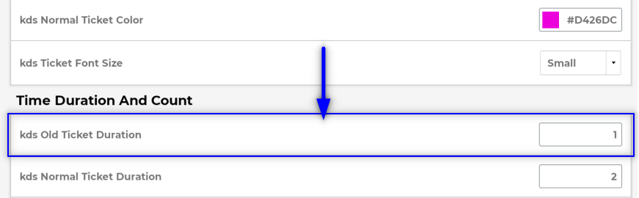

1. Search the configuration **KDS Old Ticket Duration.**

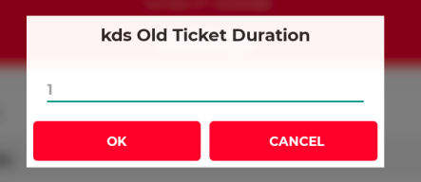

1. Enter the duration in minutes.
2. All set! Now the new ticket will turn old after the set time interval.

## Bumping the Ticket from Kitchen to Expo Screen

When an item is prepared and ready to be served, the chef can bump that item or the entire ticket to the Expo screen. This indicates that the item or order is fulfilled and ready to be served.

### Item-level bumping

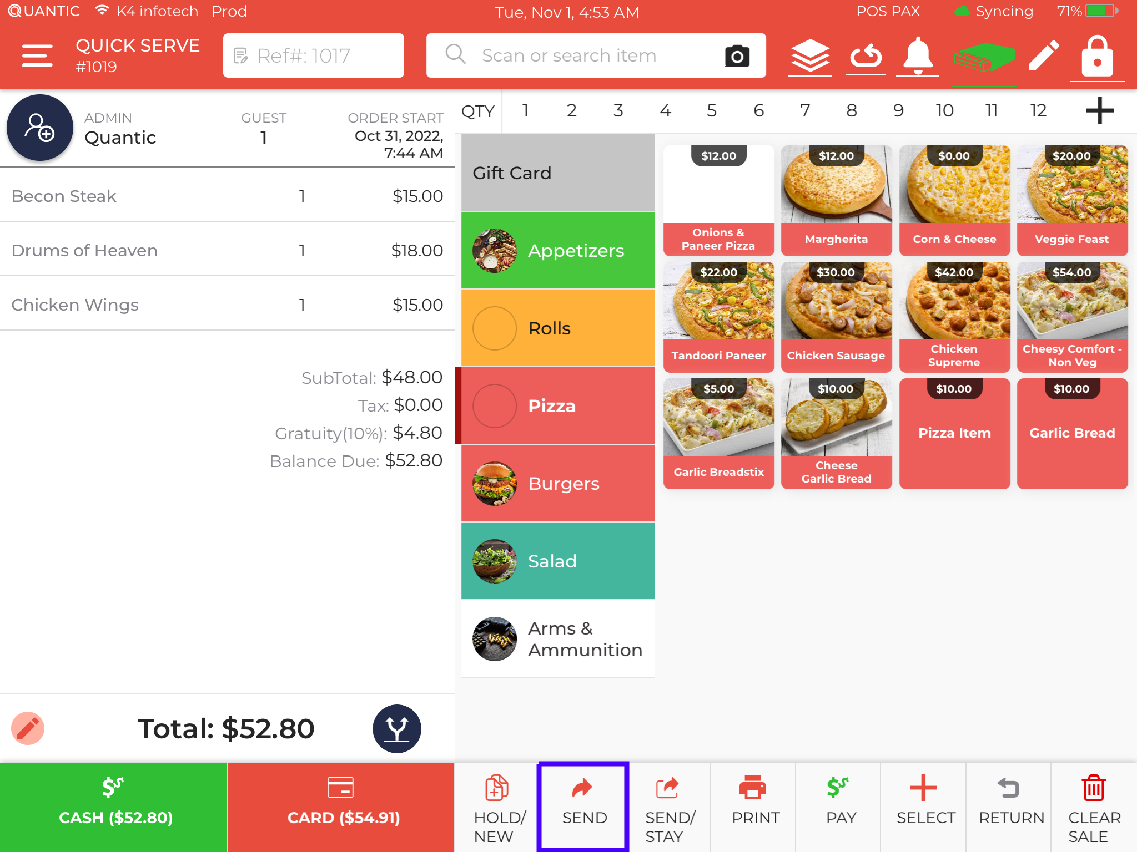

1. Send an order to the kitchen by clicking the **Send** button on the POS.

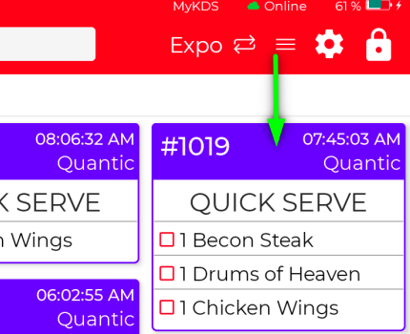

1. The ticket will be displayed on the KDS screen.

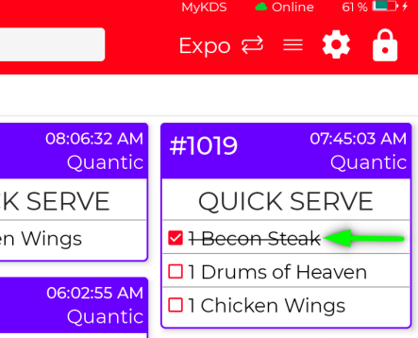

1. Once the items in the ticket are prepared (cooked), select the checkbox next to that item and it will be sent to the Expo screen.
2. To see the Expo screen, tap the  button on top of the KDS.

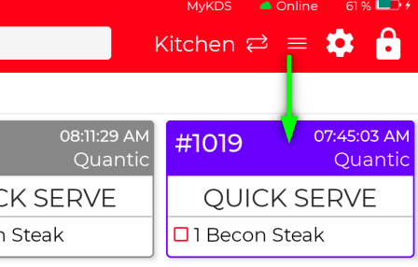

1. The order number with an item will be displayed on the Expo screen.
2. Once an item has been served, Expo can double-tap the ticket to remove it from the screen.

### Order-level bumping



1. Send an order to the kitchen by clicking the **Send** button on the POS.



1. The ticket will be displayed on the KDS screen.
2. Once all the items in the ticket are prepared (cooked), double-tap the ticket to send that order to the Expo screen.
3. To see the Expo screen, tap the  button on top of the KDS.

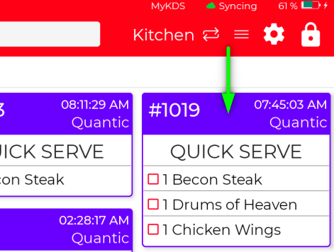

1. The order number with an item will be displayed on the Expo screen.
2. Once the order has been served, Expo can double-tap the ticket to remove it from the screen.

## Sound Notifications for New Orders on Quantic KDS

A new order accompanied by a sound notification will alert the kitchen staff immediately so that they do not need to rely on the visual updates for new orders on the KDS dashboard. The chef can then review the new order (identified by a different color) on the KDS and start preparing it. If you do not want the KDS to ring the sound notification for a new order, you will need to disable the setting from the Settings section.



1. Click the  icon on the KDS to go to **Settings**.

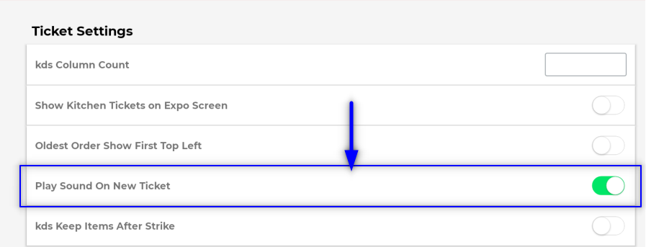

1. Search the configuration **Play Sound On New Ticket**.
2. Turn on the above configuration.
3. All set! The new order will be accompanied by a sound notification on both- Kitchen and Expo screens.